Create customdirective file under app folder

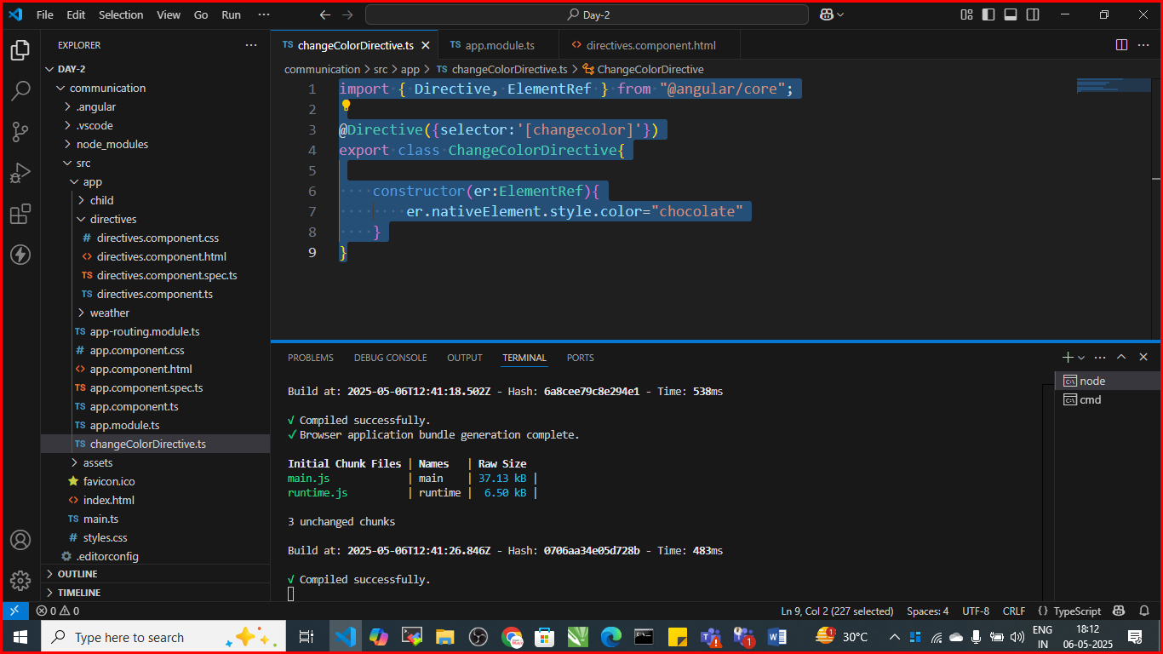

Custom Directives

import { Directive, ElementRef } from "@angular/core";

@Directive({selector:'[changecolor]'})

export class ChangeColorDirective{

    constructor(er:ElementRef){

        er.nativeElement.style.color="chocolate"

    }

}

Define in app.module.ts file

import { NgModule } from '@angular/core';

import { BrowserModule } from '@angular/platform-browser';

import { AppRoutingModule } from './app-routing.module';

import { AppComponent } from './app.component';

import { ChildComponent } from './child/child.component';

import { DirectivesComponent } from './directives/directives.component';

import { WeatherComponent } from './weather/weather.component';

import { ChangeColorDirective } from './changeColorDirective';

@NgModule({

  declarations: [

    AppComponent,

    ChildComponent,

    DirectivesComponent,

    WeatherComponent,

    ChangeColorDirective

  ],

  imports: [

    BrowserModule,

    AppRoutingModule

  ],

  providers: [],

  bootstrap: [AppComponent]

})

export class AppModule { }

use it in any component with its syntax

directive.component.html

<div class="container">

    <h2 changecolor> Change Color Directive</h2>

</div>

Save and check the output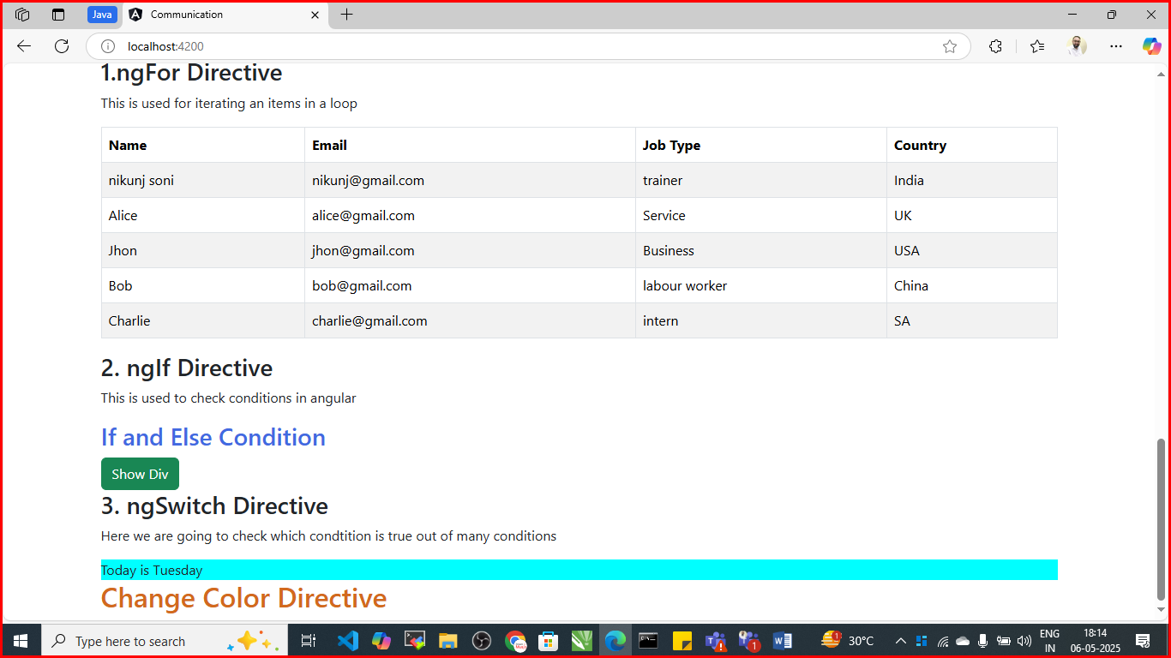

# Custom Directive Using Renderer2

Create highlightDirective.ts file under app folder

import { Directive, ElementRef,Renderer2 } from "@angular/core";

@Directive({selector:'[highlight]'})

export class HighLightDirective{

    constructor(er:ElementRef,render:Renderer2){

        render.setStyle(er.nativeElement,'background-color','lightgreen')

    }

}

Define in app.module.ts file

import { NgModule } from '@angular/core';

import { BrowserModule } from '@angular/platform-browser';

import { AppRoutingModule } from './app-routing.module';

import { AppComponent } from './app.component';

import { ChildComponent } from './child/child.component';

import { DirectivesComponent } from './directives/directives.component';

import { WeatherComponent } from './weather/weather.component';

import { ChangeColorDirective } from './changeColorDirective';

import { HighLightDirective } from './highLightDirective';

@NgModule({

  declarations: [

    AppComponent,

    ChildComponent,

    DirectivesComponent,

    WeatherComponent,

    ChangeColorDirective,

    HighLightDirective

  ],

  imports: [

    BrowserModule,

    AppRoutingModule

  ],

  providers: [],

  bootstrap: [AppComponent]

})

export class AppModule { }

use it in any of the component

directive.component.html

<div class="container">

    <h2 changecolor> Change Color Directive</h2>

    <h3 highlight>This is Highlight Directive Using Render</h3>

</div>

Save and check the output

